Relative Ages of Rocks Activity Name:____________________
Per:___ Date:______________

Using the Laws of Horizontality, Superposition, Cross Cutting Relationships, and Inclusion, demonstrate your understanding of geologic principles by unraveling the sequence of geologic events shown in each diagram. Include deposition of each rock formation (including the name of the type of rock), and any events like tilting, folding, faulting, igneous intrusion, or erosion. List the layers from oldest (on the bottom) to youngest (on top).

Sedimentary Rocks Igneous Rocks Metamorphic Rocks
Sandstone: 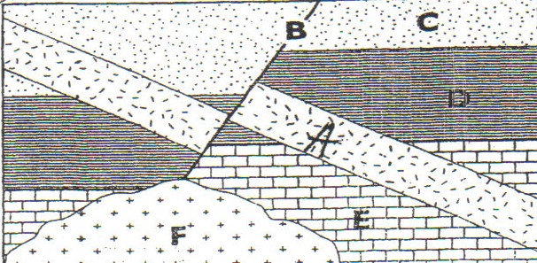 Siltstone: 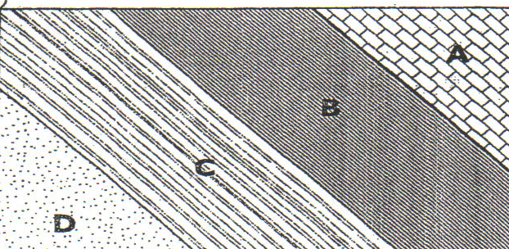 Shale: 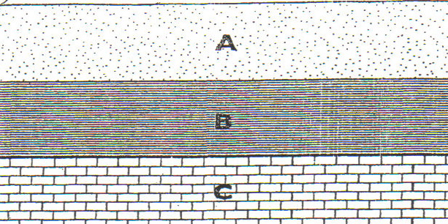

Limestone: Conglomerate: 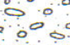

Granite: 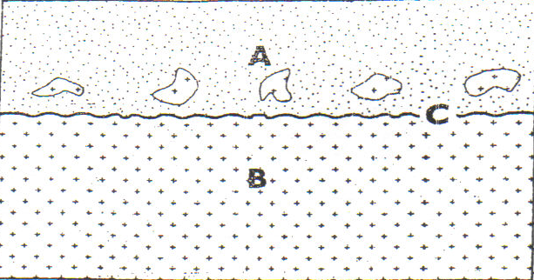

Basalt: 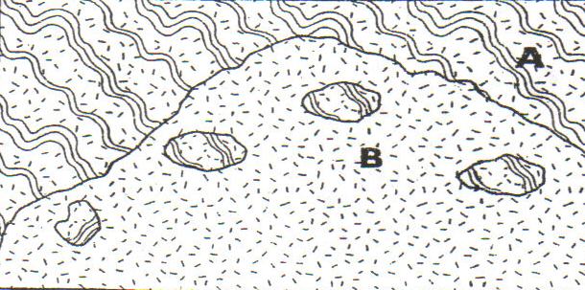

Gneiss:

Youngest
_____________________
___________________
___________________
___________________
___________________
Oldest
1. 2.
Youngest
_____________________
___________________
___________________
Oldest

3. 4.
Youngest
_____________________
___________________
___________________
Oldest
Youngest
_____________________
___________________
Oldest

5. 6.
Youngest
_____________________
___________________
___________________
___________________
___________________
___________________
Oldest
Youngest
____________________
__________________
__________________
__________________
__________________
__________________
Oldest
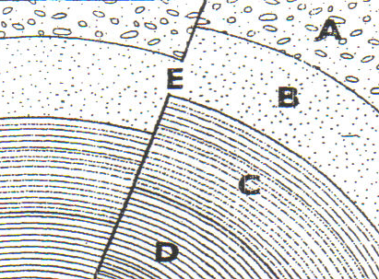

Youngest
____________________
__________________
__________________
__________________
__________________
__________________
__________________
Oldest
Youngest
____________________
__________________
__________________
__________________
__________________
__________________
__________________
__________________
__________________
Oldest
7. 8.
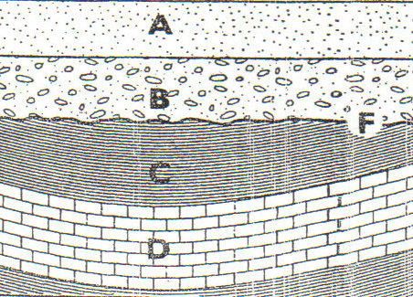
E


