Mendel and Inheritance of Traits Notes
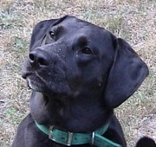
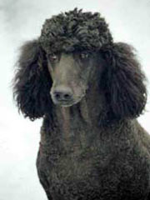
1) Heredity: passing of _________ from parent to ____________
- Trait: ________________ that an organism can pass to its offspring through ________.
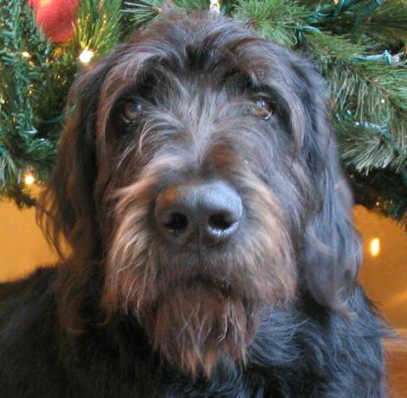
2) Genetics: the study of how traits are ____________ through the actions of alleles

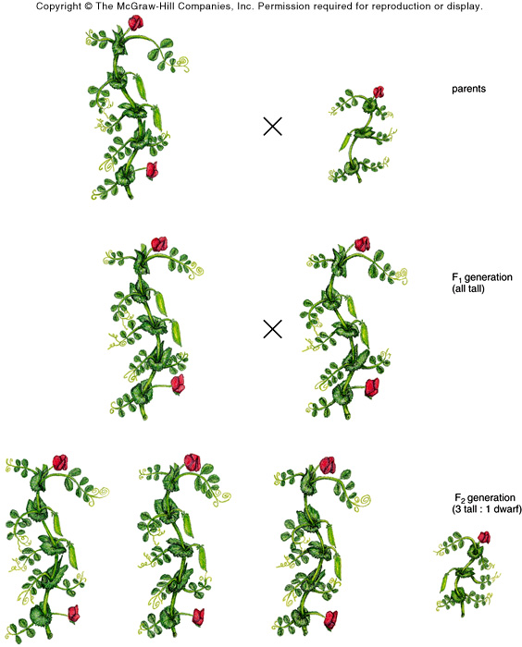
3) Gregor Mendel: the __________ of modern genetics
- Used ______ _________ to study how traits are passed from parents to offspring
parents
  - First Experiment: Crossed purebred _______ plants with purebred _______ plants
  - Results: _______- generation were _____ ________ plants (no short)
F1 Gen.
all tall
  - Second Experiment: first-generation _______ plants _______- pollinate
  - Results: ___________- generation plants were _______ and ________
F2 Gen. 3 tall &
1 short
  - There were _______ ______ plants for every _____ ________ plant (a 3:1 ratio).
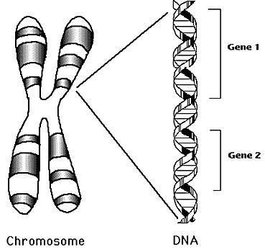
- Determined we can ____________ ________ of offspring based on the parents’ traits
- Figured out ___________ and recessive alleles

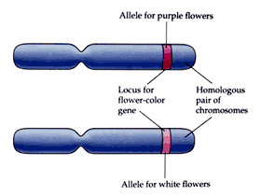
- Gene: section of DNA on a _________________ that directs the making of a specific ___________
  - An organism’s genes are inherited from its _____________.

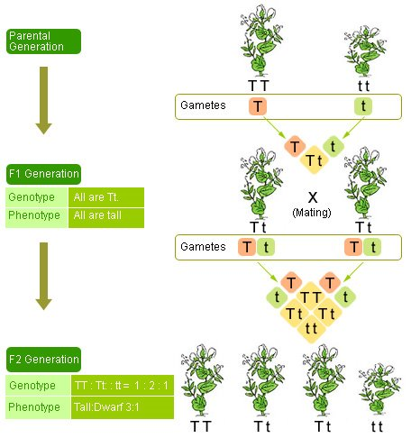
5) Allele: the different forms a ________ may have for a trait
  - Alleles can be ____________ or _____________
  - Dominant: ________ up or masks the ___________. We only see the dominant trait.
  - Use ___________ letters to represent dominant traits. Ex: T or P
  - Recessive: __________ by the dominant allele. We only see if _______ ________ for the trait are ____________.
  - Use _______ case letters to represent recessive traits. Ex: t or p

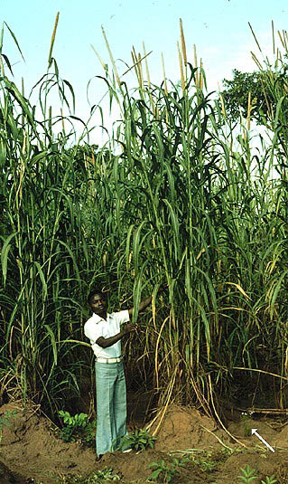
6) Genotype: the genetic ____________ of an organism (its alleles)
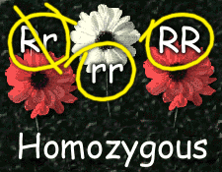
- It is written with letters such as _____ or _____ or _____.
- Homozygous: having two _________ that are the __________ for a trait
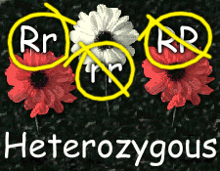
  - Example: _____ or _____
- Heterozygous: having two _____________ alleles for a trait
  - Example: _____

7) Phenotype: the ____________ expression of a particular ____________
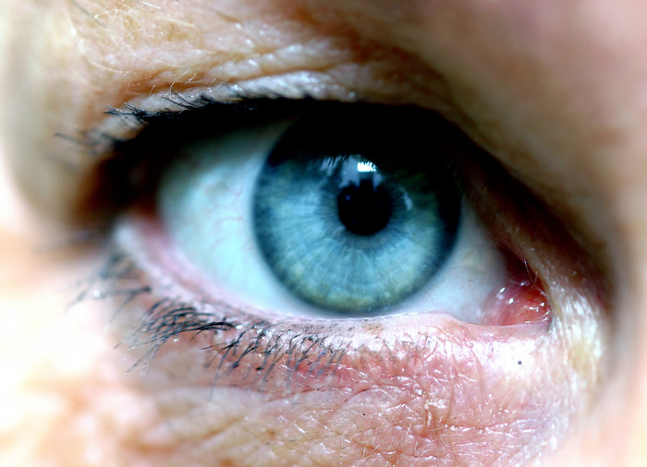
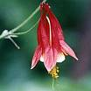
- It is what a ________ looks like
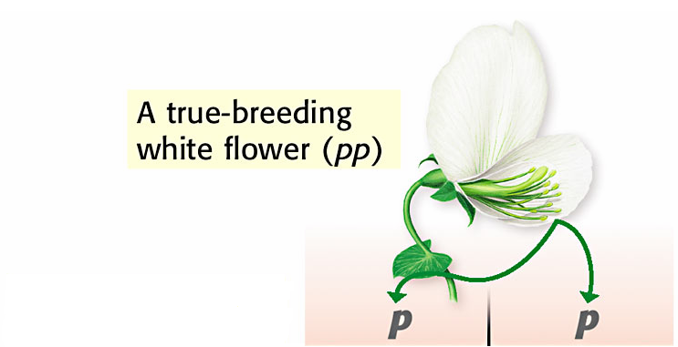
- Example: blue eyes, _____ _________, tall plants, etc.

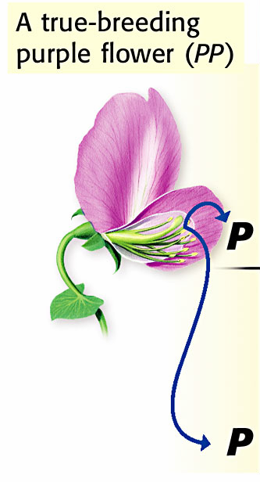
8) Punnett Squares:
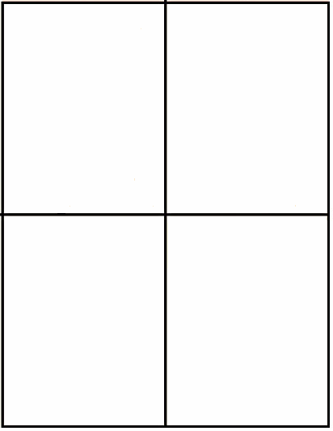
- A Punnett square ________ how the parents’ ________ might ___________ in offspring.
- The ______ of the square shows _____ __________ ________ for the trait.
- The _______ of the square shows the _________ parent’s ________ for the trait.
- Each _____ shows one way the ________ might __________ in potential ____________.
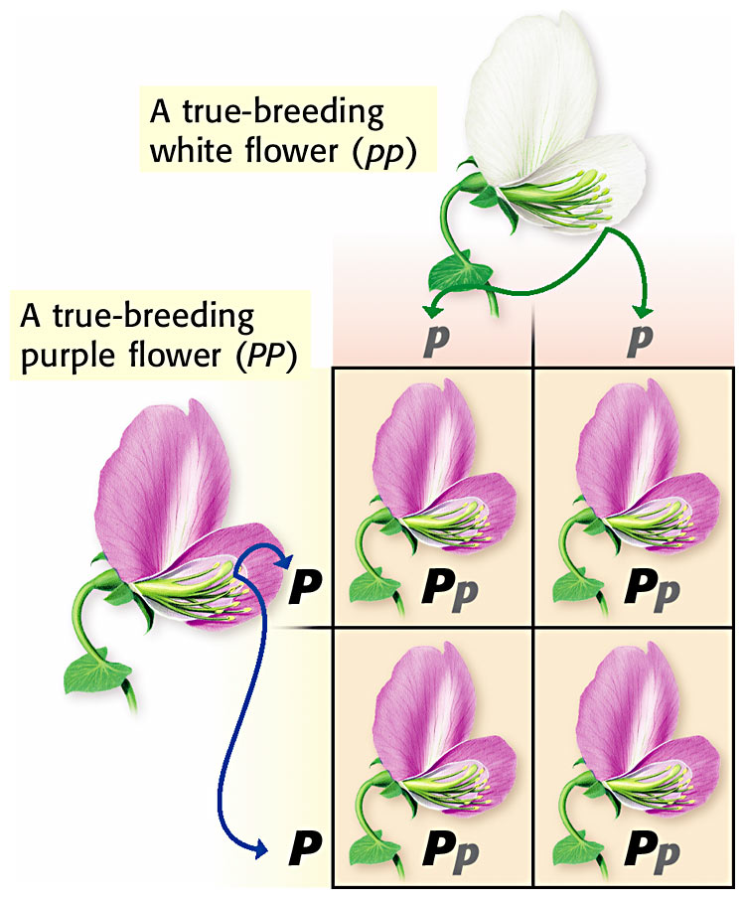
- Ex 1: • Ex 2:

