**Light & the Electromagnetic Spectrum Notes**

**1. Light**

***\*Draw light rays leaving a source***

* Light is a form of ________ that travels as an electromagnetic wave.
  + Electromagnetic waves are made of _________ and ___________ fields.
  + EM waves can travel through _________ _________ and ___________.
* Light travels in a __________ line



* + Draw light leaving a source: use straight ________ with __________ at end to show ______________ light is traveling.
  + Light is ______________ from a light source (light bulb, sun, flame, etc).

***\*Light bulb emits light into your eye***

* + Emit: to _________ forth/out from (a light source).

**2. Electromagnetic Spectrum**

* Electromagnetic Spectrum is the entire _________ of all the __________________ waves.

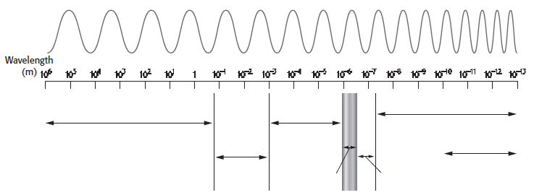

* ________________: longest wavelength, lowest frequency, lowest energy, ___________ sources.
* ________________: shortest wavelength, highest frequency, highest energy, __________ sources.

**3. Wavelength and Frequency**

* All ___________ have both a wavelength and a frequency.
  + _____________________: the distance between the tops or crests of two waves.

(draw the wave and label)

* + ______________________: the number of waves that pass a point in 1 second.
    - the more crests that pass a point in 1 second, the ___________ the frequency.

(draw both waves and label)

**4. Visible Light**

* Very ________ part of electromagnetic spectrum you _______ _______.
* Energy from the _______ reaches Earth as __________ light. It is a _____________ of all __________ of light.
* White light can be divided into __________ according to _________________.
* Can use a _________ to split white light into different wavelengths.

(draw light entering prism, and the different colors coming out)

* Each color has a ___________ wavelength.
* R: _____________________________
* O: _____________________________
* Y: _____________________________
* G: _____________________________
* B: _____________________________
* I: _____________________________
* V: _____________________________

**5. Infrared Waves**

* Range from _____ nm to ___ mm.
* __________ wavelength than ________ light.
* ________ the Earth & keeps temperature suitable for life.

**6. Ultraviolet Light**

* Range from ____ nm to _____ nm.
* ___________ wavelength than __________ light.
* Some animals like _______ can ______ _____ (ultraviolet) light.