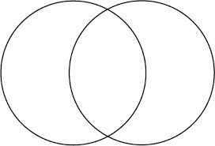

**-**Changes in an organism are influenced by what the organism _________ or ________ and then over many generations the _______ are born with these changes.

**-**Individual structures (body parts) of an organism __________ in size by ___________ and __________ in size when ___________.

**Objective:** Students will be able to __________ three scenarios of Darwin and Lamarck’s theory of ____________ on a worksheet provided in class.

**-**Organisms __________ to work better in their _________________.

**-**Organisms have evolved (___________) over time and are still evolving.

**-**Offspring are born with their parents ___________ traits and as they _____________ those traits become more dominant.

**-**Organisms that have___________ will adapt to their _______________ and have more _______________.

**Darwin**

**Lamarck**