Earth’s History & Geologic Time Notes

How Changes Occur on the Earth
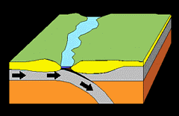
- Plate Tectonics: theory of how Earth’s tectonic _________ move and _________ in ________
- plates move an average of ________ a year and in _________ different ways
- convergent boundary: plates move ___________ each other
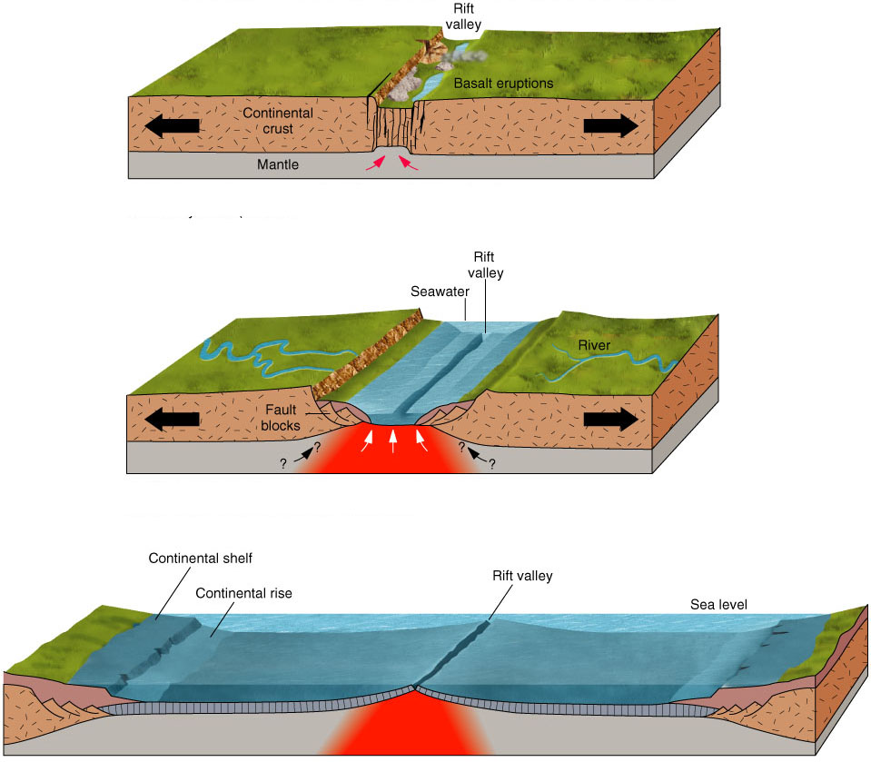
- plates can _________ to form _____________ or one plate can ________ _________ another plate creating a line of _____________
- divergent boundary: plates move _________ from each other
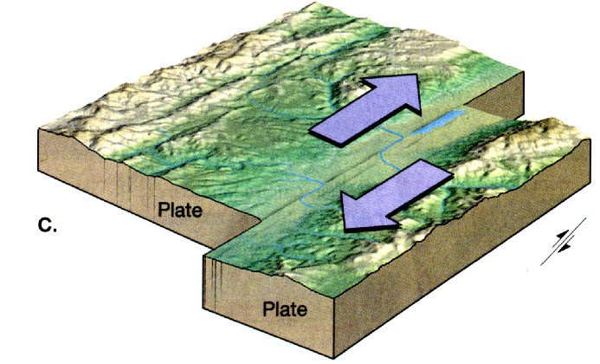
- new ________ ________ here; could be new ________ floor or _______________ crust
- transform boundary: plates _______ ________ each other creating _____________
- Continental Drift: describes that as tectonic __________ move, _____________ have _________ with them changing the Earth’s surface

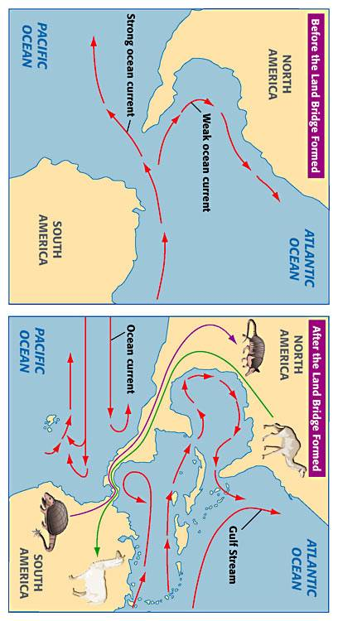
Affects of Earth Changes
- As ________ and continents ________ together and ________, there are many consequences
- can _________ how ________ currents and ________ patterns flow on the Earth
- these changes affect the ________ of ________ around the Earth which can cause ____________ in ____________
- can cause the ________________ of new ____________ and environments
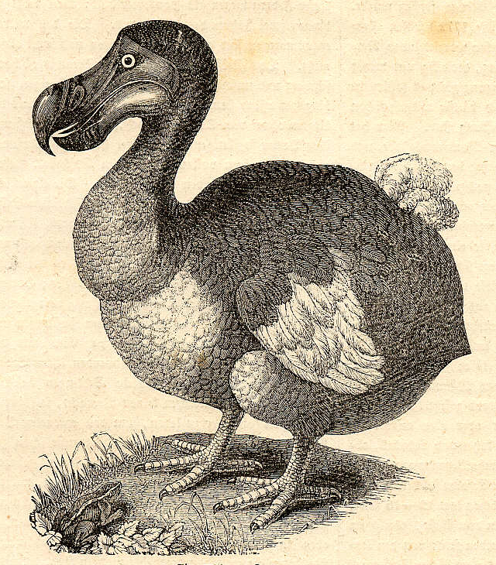
- can ___________ existing habitats and ________________
- ______________ are ___________ by the changes caused by plate tectonics
- organisms will either _________ to the __________ (evolve) or become __________
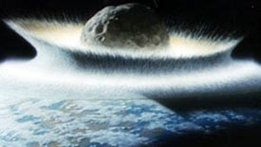
- extinction: the _________ of every member of a ___________
- some earth changes ______ _________ in the ________ ____________ of organisms
- mass extinction: the ________ of ________ species around the _______ _______
- could be caused by __________ events, like ________ change and changes in ocean currents, or _________________ events, like an ___________ impact

Geologic Time Scale
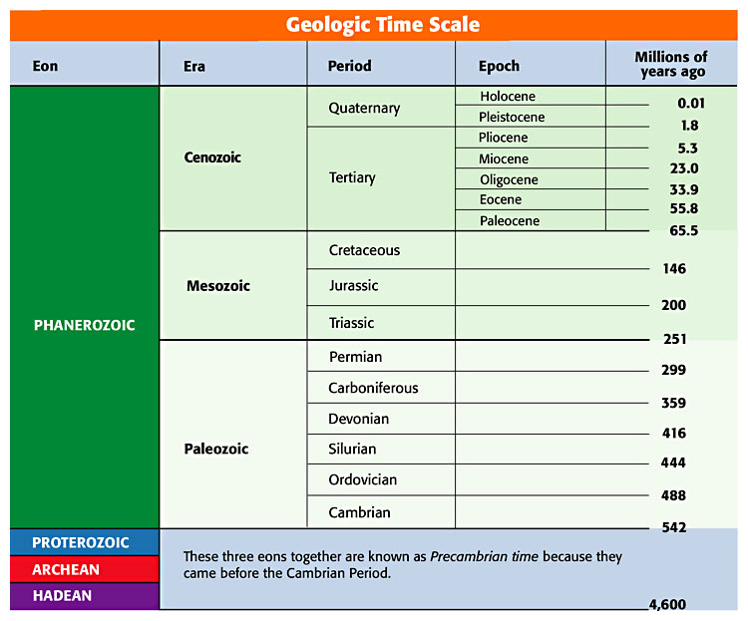
- Developed ___________ _______ ________ to break up Earth’s history into _________ _______
- Geologic time scale has ____ major __________ of time:
- ______ are the _________ division, followed by ______, then _________ and finally _________ (the _________ division of the four)
- divisions of the time scale are __________ by _______ _________ in Earth’s history
- major _________ in _________ things, _____________ of living things and changes in the ________ __________ decide how to divide Earth’s history

Precambrian Time: 4.6 billion years ago to 542 million years ago
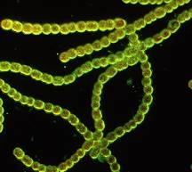
- First organisms called _______________ (cells without a nucleus) appeared in _________ more than _____ billion years ago
- Cyanobacteria: type of prokaryote that ______ _______________ to make own food.
- Photosynthesis __________ __________ into the atmosphere and began to build up over millions of years.
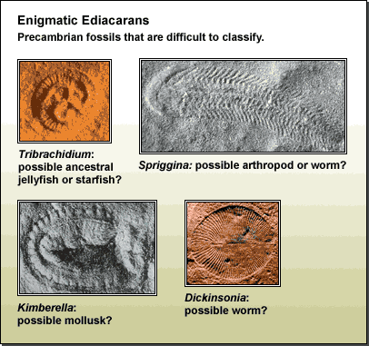
- Oxygen build-up led to the formation of ________ which ___________ organisms from the harmful ___________ of the sun
- Allowed for development of _________ organisms & for __________ to survive on ______
- After about 1 billion years ______________ (cells with a nucleus) began to _________
- Invertebrates (animals ___________ backbones) developed near the _____ of the ____________

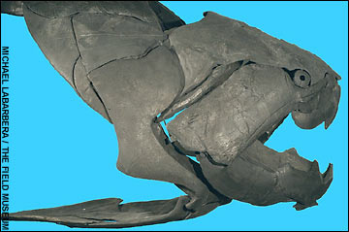
Paleozoic Era (ancient life): 542 - 251 million years ago
- First organisms with _________ body _________ (shells, exoskeletons & bones) evolved
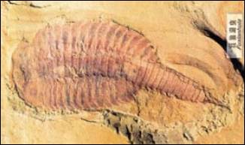
- Broken into _____ periods
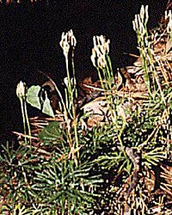
  - Cambrian: ________ animals with hard body parts
2. Ordovician: Early vertebrates appeared (animal _______ ____________)
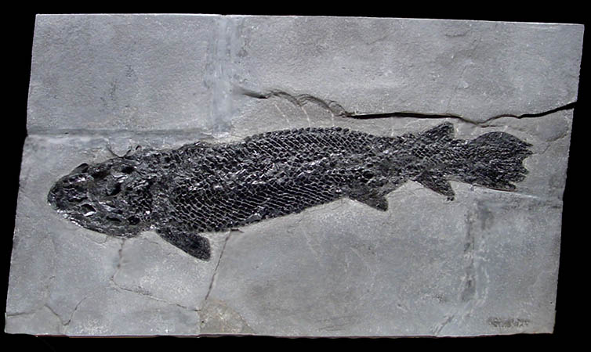
3. Silurian: _______ life on land evolved
4. Devonian: _______ evolved and were ____________; early ____________ show up in the fossil record
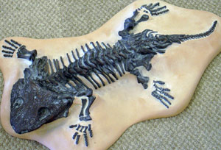
5. Carboniferous: divided into _________________ & Pennsylvanian in U.S.
- Mississippian: ______________ were the ___________ vertebrate
- Pennsylvanian: early _________ emerge
Pangea
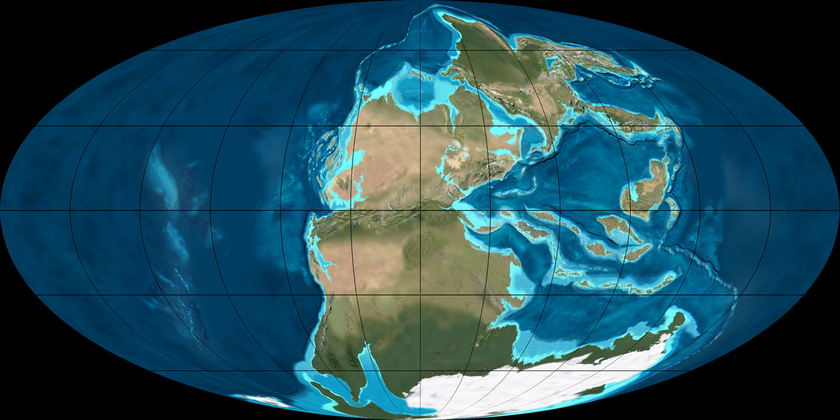
- Permian: formation of the large land mass called __________ caused _______ of coastal _________ and climate change
  - Period ended with a mass extinction of _____% of all organisms due to ________ in the _______________ caused by plate tectonics

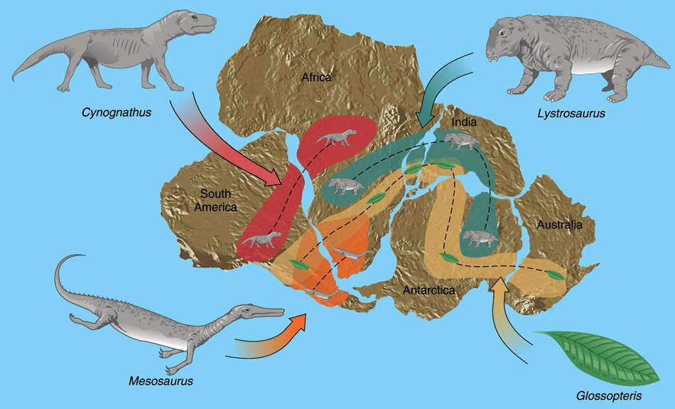
Mesozoic Era (middle life): 251 - 65 million years ago
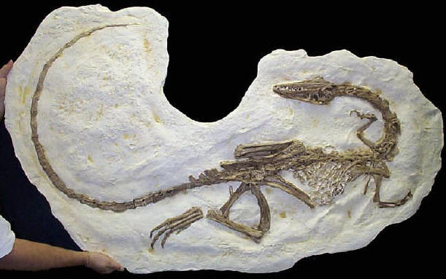
- Era known as “_____ of ___________” and broken into 3 periods
1. Triassic: time of ____________
- small _____________ evolved
- Pangaea _________ during much of the Triassic
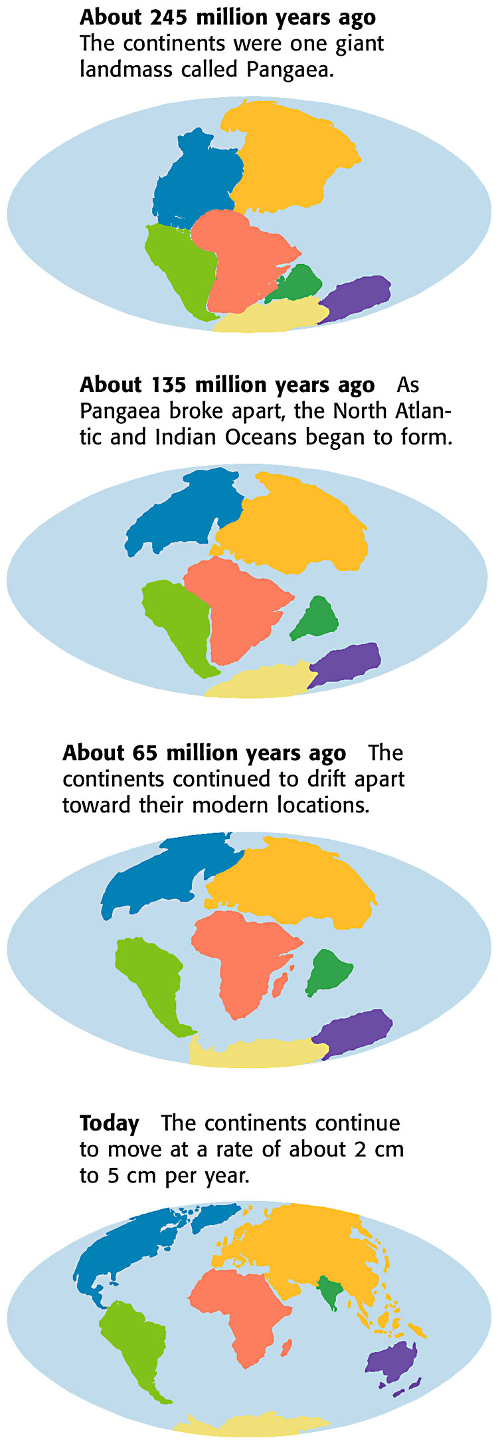
- allowed for ____________ left after Permian mass extinction to _________ over the _________ (allowed for _____________ of organisms)
Break-up of Pangea
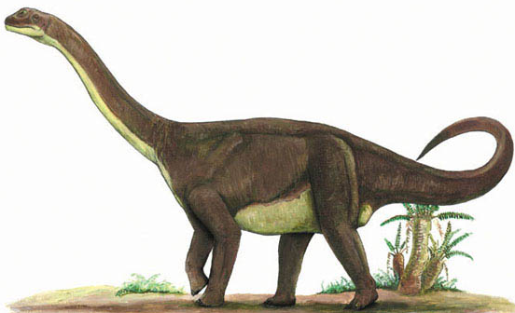
2. Jurassic: _____________ were ___________
- _________ species of ____________ evolved
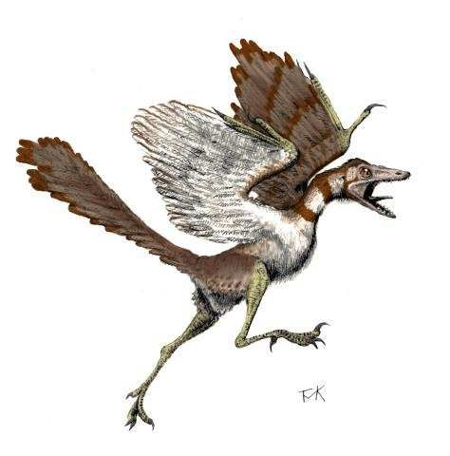
- Pangaea ___________ throughout the period
- _______ are thought to have __________ from ________________
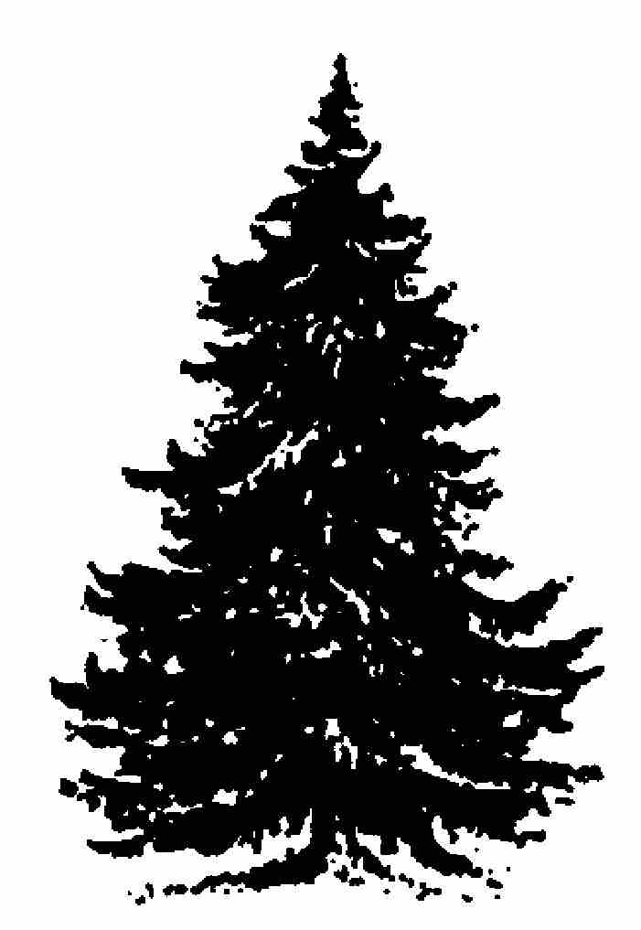
- Archaeopteryx: wings & __________ like birds, but ________ & ________ like dinosaurs
- Cretaceous: dinosaurs still dominant; modern insect, _______ & mammal groups appear
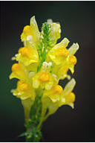
  - pine, ____________, and fir ________ evolved
  - ____________ plants (angiosperms) are still ____________ today
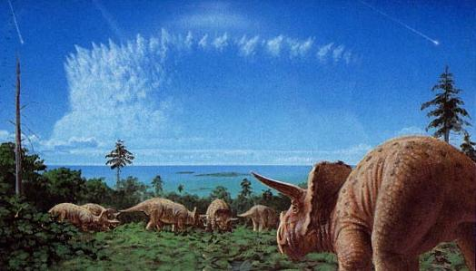
  - increased ____________ activity
  - ____________ became __________ at the end; __________ environments

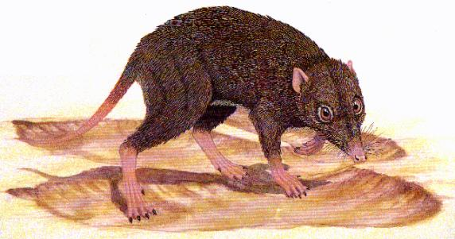
Cenozoic Era (recent life): 65 million years ago to the present
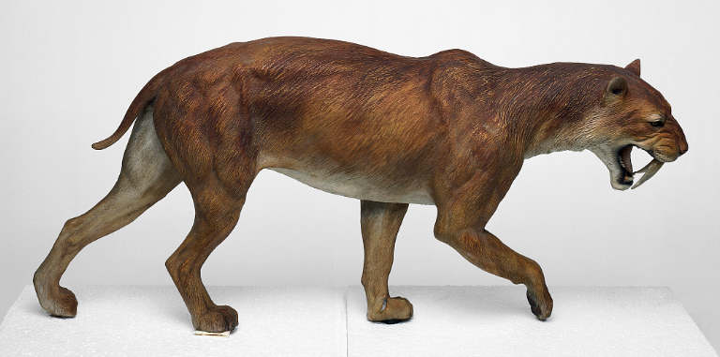
- Early in Cenozoic ___________ were small, but __________ into many different _______ over the era, including _________ mammals
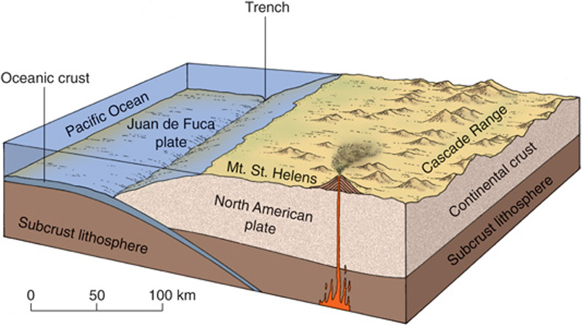
- Times of _____________ building: Sierra Nevada, ____________ & Andes Mountain ranges form
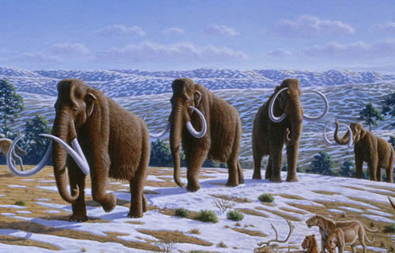
- Periods of _________ climates and _____ _______: some ________ ________ towards the equator (warmer climates) and _________ became __________
- ______ still _____________ today

