Benchmark Light and Eye Study Guide
Name _________________ Period _______
1. The lens of the eye is shaped like a convex lens, thick in the middle and thin at the ends. The advantage in having a lens with this shape is the light can be F_____________________________.
2. Describe the functions of rod and cone cells in the eye.
Rods - _______________________________ Cones - _____________________________
3. Arrange these words to show the correct pathway followed by light as it travels through the eye to form images – retina, lens, pupil and cornea. ___________________________________________
4. The protective covering for the eye - C____________________________
5. If a person has a problem with their night vision is probably due to a problem with their R__________.
6. Draw the electromagnetic spectrum and circle the area that is visible to the human eye.

7. The range of light in the EM spectrum that honeybees can see but is not visible to humans is called the ____________________________________.
8. Your dog does not emit light, but you can still see him. Explain, how this is possible? ______________
_____________________________________________________________________________________
9. Explain why we see a green apple as the color green? _______________________________________
_____________________________________________________________________________________
10. Place these three words in the correct order, so that your eye can perceive an image –
eye – light source – object ___________________________________________________________
11. Light always moves in a S_______________________ line.
12. A ray of light reflected from a mirror, shows that light travels in a S___________________line.
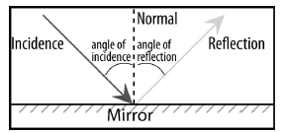
13. A straw in a glass of water will appear broken, when viewed from the side. This is an example of refraction, when light goes through two mediums – air and water. To make the straw appear whole, what should be done? ______________________________________________________________
14. Stars appear to twinkle because the light from the stars changes d______________________ as it passes through the swirling atmosphere.
15. The c___________________ lens is the best lens to use for the objective lens.
16. What is the function (purpose) of the lens of the eye? __________________________
17. In this simple camera, which part functions the same as the lens in the human eye? _____________
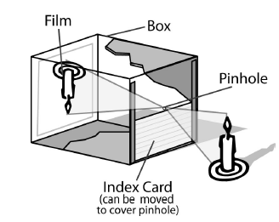
18. If someone is unable to see black, white and gray, they lack the cells in their eyes that allow them to see different W____________________________________________ of light.
19. To see different colors, the retina must be able to determine this property of light – W____________
20. If the cone cells can see three different colors, they are actually seeing different W_________________ of light.
21. Light that comes out of a prism is a rainbow of colors. What is the source of the colors? W________________________ that enters the prism
22. White light is a mixture of which colors? _________________________________________________
23. Light passing through a prism changes into a rainbow of colors, because the prism splits the light into D________________________ W_______________________
24. Which part of your eye dilates (larger), when all of the lights are turned off in your classroom? P____
25. When light hits the lens inside of the eye, the lens causes the light to be __________so the object is brought into focus.
26. The angle of reflection measures 22 degrees. Then, what is the angle of incidence? ____
27. If light is reflected it ___________________. If light is refracted it _______.
28. On a green leaf, only green light is reflected. What happens to rest of the light? ____________

